RAID stands for Redundant Array of Inexpensive (Independent) Disks.

On most situations you will be using one of the following four levels of RAIDs.

* RAID 0
* RAID 1
* RAID 5
* RAID 10 (also known as RAID 1+0)

This article explains the main difference between these raid levels along with an easy to understand diagram.  
  
In all the diagrams mentioned below:

* A, B, C, D, E and F – represents blocks
* p1, p2, and p3 – represents parity

**RAID LEVEL 0**

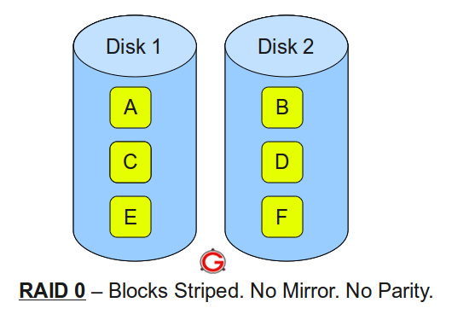  
Following are the key points to remember for RAID level 0.

* Minimum 2 disks.
* Excellent performance (as blocks are striped).
* No redundancy (no mirror, no parity).
* Don’t use this for any critical system.

RAID LEVEL 1

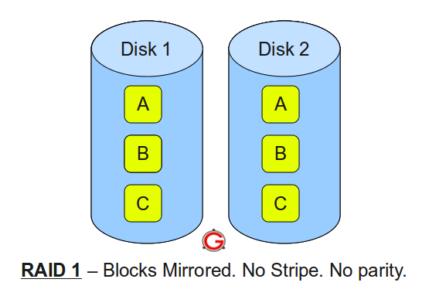Following are the key points to remember for RAID level 1.

* Minimum 2 disks.
* Good performance (no striping. no parity ).
* Excellent redundancy (as blocks are mirrored).

RAID LEVEL 5

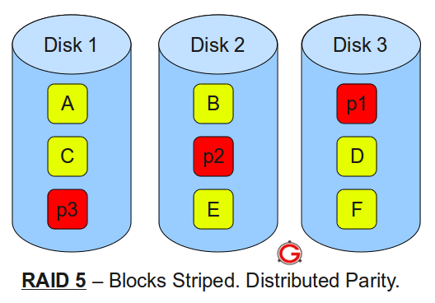  
Following are the key points to remember for RAID level 5.

* Minimum 3 disks.
* Good performance (as blocks are striped).
* Good redundancy (distributed parity).
* Best cost effective option providing both performance and redundancy. Use this for DB that is heavily read oriented. Write operations will be slow.

RAID LEVEL 10

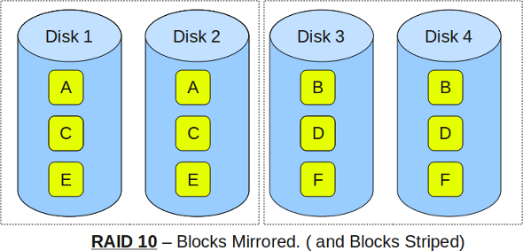

Following are the key points to remember for RAID level 10.

* Minimum 4 disks.
* This is also called as “stripe of mirrors”
* Excellent redundancy ( as blocks are mirrored )
* Excellent performance ( as blocks are striped )
* If you can afford the dollar, this is the BEST option for any mission critical applications (especially databases).

Armstrong’s Axioms in Functional Dependency in DBMS

The term Armstrong axioms refer to the sound and complete set of inference rules or axioms, introduced by William W. Armstrong, that is used to test the logical implication of **functional dependencies**. If F is a set of functional dependencies, then the closure of F, denoted as , is the set of all functional dependencies logically implied by F. Armstrong’s Axioms are a set of rules, that when applied repeatedly, generates a closure of functional dependencies.

F+

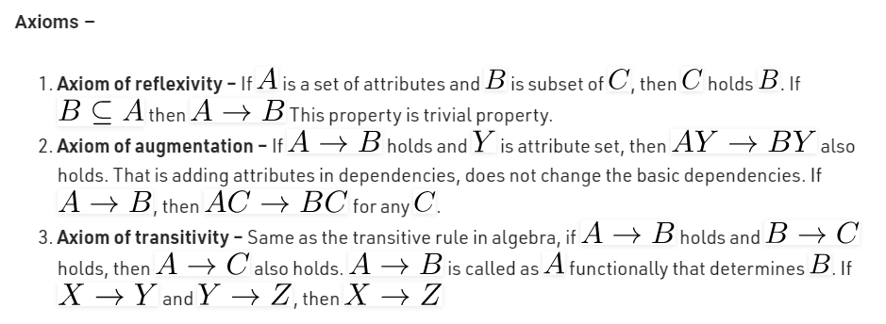

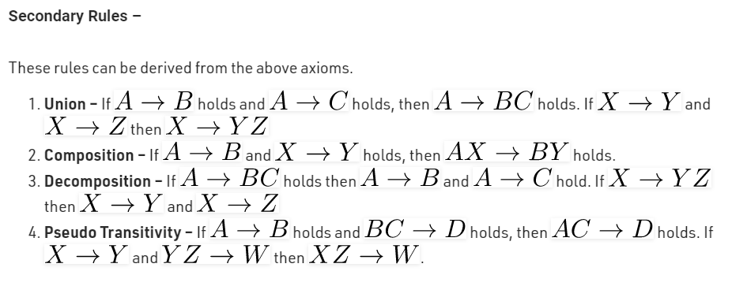.

**Why Armstrong axioms refer to the Sound and Complete?**

By sound, we mean that given a set of functional dependencies F specified on a relation schema R, any dependency that we can infer from F by using the primary rules of Armstrong axioms holds in every relation state r of R that satisfies the dependencies in F.  
By complete, we mean that using primary rules of Armstrong axioms repeatedly to infer dependencies until no more dependencies can be inferred results in the complete set of all possible dependencies that can be inferred from F.

**DBMS - File Structure**

Relative data and information are stored collectively in file formats. A file is a sequence of records stored in binary format. A disk drive is formatted into several blocks that can store records. File records are mapped onto those disk blocks.

File Organization

File Organization defines how file records are mapped onto disk blocks. We have four types of File Organization to organize file records −

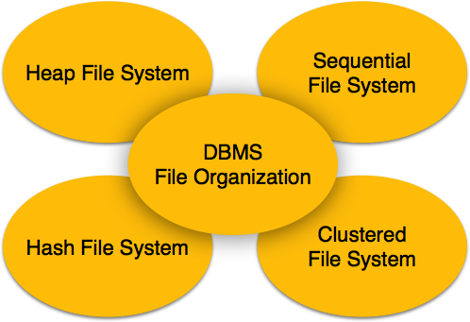

Heap File Organization

When a file is created using Heap File Organization, the Operating System allocates memory area to that file without any further accounting details. File records can be placed anywhere in that memory area. It is the responsibility of the software to manage the records. Heap File does not support any ordering, sequencing, or indexing on its own.

Sequential File Organization

Every file record contains a data field (attribute) to uniquely identify that record. In sequential file organization, records are placed in the file in some sequential order based on the unique key field or search key. Practically, it is not possible to store all the records sequentially in physical form.

Hash File Organization

Hash File Organization uses Hash function computation on some fields of the records. The output of the hash function determines the location of disk block where the records are to be placed.

Clustered File Organization

Clustered file organization is not considered good for large databases. In this mechanism, related records from one or more relations are kept in the same disk block, that is, the ordering of records is not based on primary key or search key.

File Operations

Operations on database files can be broadly classified into two categories −

* **Update Operations**
* **Retrieval Operations**

Update operations change the data values by insertion, deletion, or update. Retrieval operations, on the other hand, do not alter the data but retrieve them after optional conditional filtering. In both types of operations, selection plays a significant role. Other than creation and deletion of a file, there could be several operations, which can be done on files.

* **Open** − A file can be opened in one of the two modes, **read mode** or **write mode**. In read mode, the operating system does not allow anyone to alter data. In other words, data is read only. Files opened in read mode can be shared among several entities. Write mode allows data modification. Files opened in write mode can be read but cannot be shared.
* **Locate** − Every file has a file pointer, which tells the current position where the data is to be read or written. This pointer can be adjusted accordingly. Using find (seek) operation, it can be moved forward or backward.
* **Read** − By default, when files are opened in read mode, the file pointer points to the beginning of the file. There are options where the user can tell the operating system where to locate the file pointer at the time of opening a file. The very next data to the file pointer is read.
* **Write** − User can select to open a file in write mode, which enables them to edit its contents. It can be deletion, insertion, or modification. The file pointer can be located at the time of opening or can be dynamically changed if the operating system allows to do so.
* **Close** − This is the most important operation from the operating system’s point of view. When a request to close a file is generated, the operating system
  + removes all the locks (if in shared mode),
  + saves the data (if altered) to the secondary storage media, and
  + releases all the buffers and file handlers associated with the file.

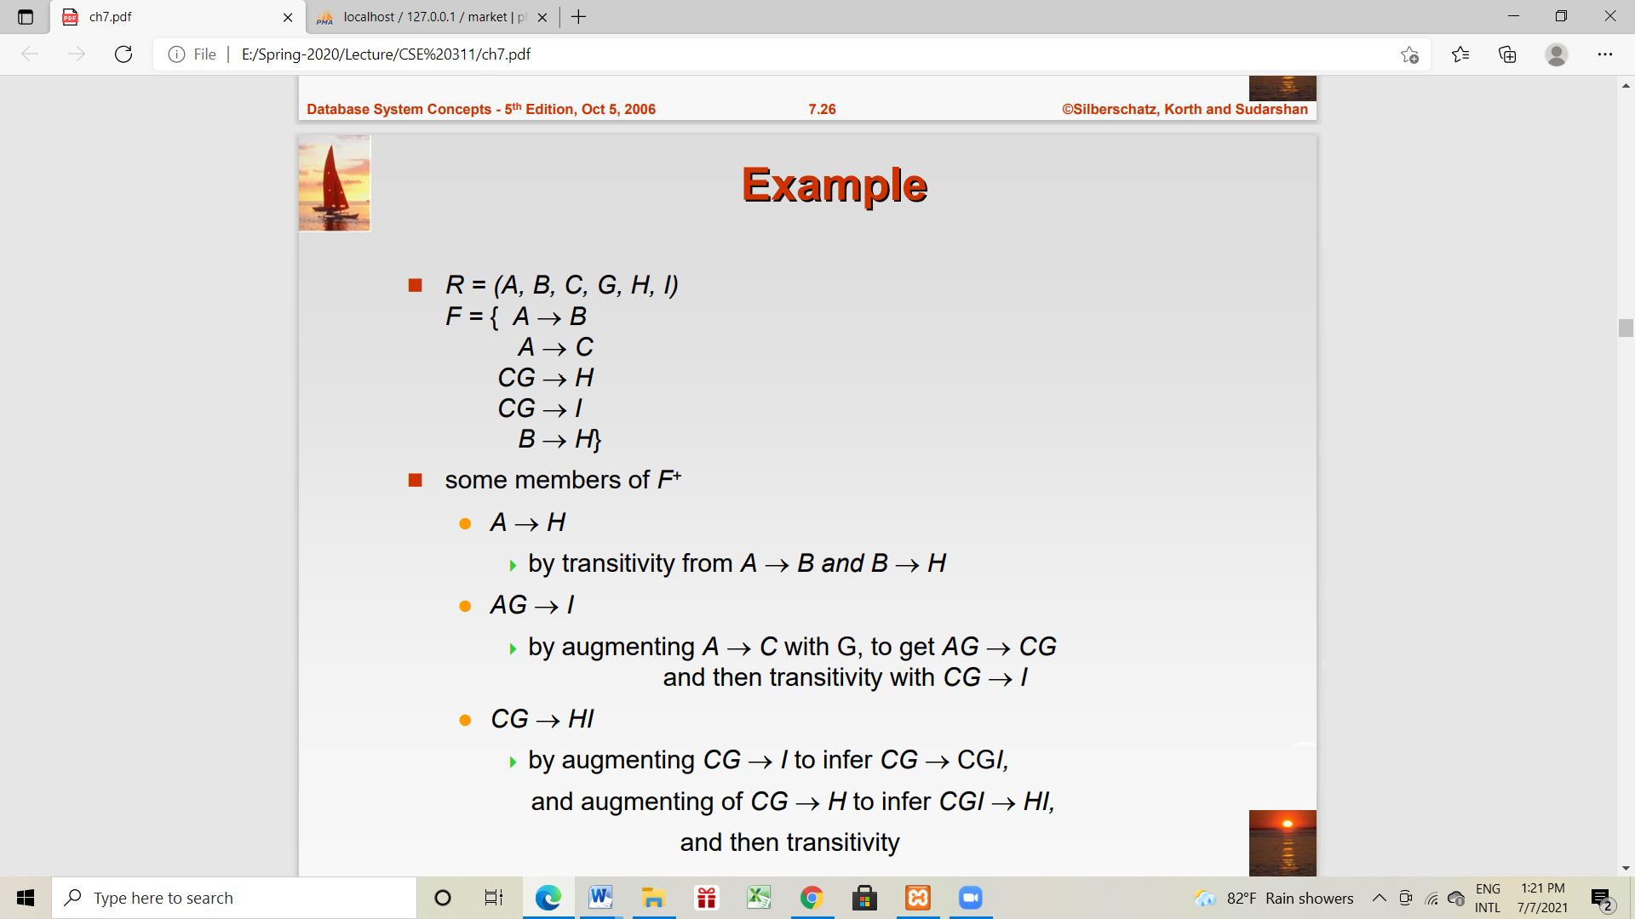The organization of data inside a file plays a major role here. The process to locate the file pointer to a desired record inside a file various based on whether the records are arranged sequentially or clustered.

**Functional Dependency**

The attributes of a table is said to be dependent on each other when an attribute of a table uniquely identifies another attribute of the same table.

For example: Suppose we have a student table with attributes: Stu_Id, Stu_Name, Stu_Age. Here Stu_Id attribute uniquely identifies the Stu_Name attribute of student table because if we know the student id we can tell the student name associated with it. This is known as functional dependency and can be written as Stu_Id->Stu_Name or in words we can say Stu_Name is functionally dependent on Stu_Id.

**Formally**:  
If column A of a table uniquely identifies the column B of same table then it can represented as A->B (Attribute B is functionally dependent on attribute A)

**Types of Functional Dependencies**

* [**Trivial functional dependency**](http://beginnersbook.com/2015/04/trivial-functional-dependency-in-dbms/)
* [**non-trivial functional dependency**](http://beginnersbook.com/2015/04/non-trivial-functional-dependency-in-dbms/)
* [**Multivalued dependency**](http://beginnersbook.com/2015/04/multivalued-dependency-in-dbms/)
* [**Transitive dependency**](http://beginnersbook.com/2015/04/transitive-dependency-in-dbms/)

# Trivial functional dependency in DBMS with example

The dependency of an attribute on a set of attributes is known as trivial functional dependency if the set of attributes includes that attribute.

**Symbolically**: A ->B is trivial functional dependency if B is a subset of A.

The following dependencies are also trivial: A->A & B->B

**For example**: Consider a table with two columns Student_id and Student_Name.

{Student_Id, Student_Name} -> Student_Id is a trivial functional dependency as Student_Id is a subset of {Student_Id, Student_Name}.  That makes sense because if we know the values of Student_Id and Student_Name then the value of Student_Id can be uniquely determined.

Also, Student_Id -> Student_Id & Student_Name -> Student_Name are trivial dependencies too.

# Non trivial functional dependency in DBMS

If a functional dependency X->Y holds true where Y is not a subset of X then this dependency is called non trivial Functional dependency.

**For example**:  
An employee table with three attributes: emp_id, emp_name, emp_address.  
The following functional dependencies are non-trivial:  
emp_id -> emp_name (emp_name is not a subset of emp_id)  
emp_id -> emp_address (emp_address is not a subset of emp_id)

On the other hand, the following dependencies are trivial:  
{emp_id, emp_name} -> emp_name [emp_name is a subset of {emp_id, emp_name}]

**Completely non trivial FD**:  
If a FD X->Y holds true where X intersection Y is null then this dependency is said to be completely non trivial function dependency.

# Multivalued dependency in DBMS

Multivalued dependency occurs when there are more than one **independent** multivalued attributes in a table.

**For example**: Consider a bike manufacture company, which produces two colors (Black and red) in each model every year.

|  |  |  |
| --- | --- | --- |
| bike_model | manuf_year | Color |
| M1001 | 2007 | Black |
| M1001 | 2007 | Red |
| M2012 | 2008 | Black |
| M2012 | 2008 | Red |
| M2222 | 2009 | Black |
| M2222 | 2009 | Red |

Here columns manuf_year and color are independent of each other and dependent on bike_model. In this case these two columns are said to be multivalued dependent on bike_model. These dependencies can be represented like this:

bike_model ->> manuf_year

bike_model ->> color

# Transitive dependency in DBMS

A functional dependency is said to be transitive if it is indirectly formed by two functional dependencies. For e.g.

X -> Z is a transitive dependency if the following three functional dependencies hold true:

* X->Y
* Y does not ->X
* Y->Z

**Note:** A transitive dependency can only occur in a relation of three of more attributes. This dependency helps us normalizing the database in 3NF (3rd Normal Form).

**Example**: Let’s take an example to understand it better:

|  |  |  |
| --- | --- | --- |
| **Book x** | **Author y** | **Author_age z** |
| Game of Thrones | George R. R. Martin | 66 |
| Harry Potter | J. K. Rowling | 49 |
| Dying of the Light | George R. R. Martin | 66 |

* X->Y
* Y does not ->X
* Y->Z  
  {Book} ->{Author} (if we know the book, we knows the author name)

{Author} does not ->{Book}

{Author} -> {Author_age}

Therefore as per the rule of **transitive dependency**: {Book} -> {Author_age} should hold, that makes sense because if we know the book name we can know the author’s age.

**Normalization**

The inventor of the relational model Edgar Codd proposed the theory of normalization with the introduction of First Normal Form, and he continued to extend theory with Second and Third Normal Form. Later he joined with Raymond F. Boyce to develop the theory of Boyce-Codd Normal Form.

Theory of Data Normalization in SQL is still being developed further. For example, there are discussions even on 6th Normal Form. **However, in most practical applications, normalization achieves its best in 3rd Normal Form**. The evolution of Normalization theories is illustrated below-



**Database Normalization Examples -**

Assume a video library maintains a database of movies rented out. Without any normalization, all information is stored in one table as shown below.

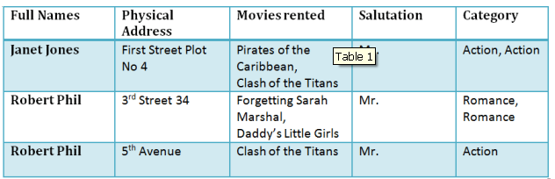

Here you see **Movies Rented column has multiple values**.

**Database Normal Forms**

Now let's move into 1st Normal Forms

## **1NF (First Normal Form) Rules**

* Each table cell should contain a single value.
* Each record needs to be unique.

The above table in 1NF-

### 1NF Example

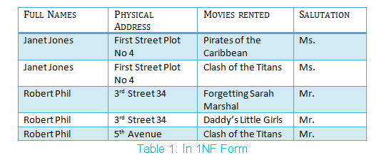

Before we proceed let's understand a few things --

## What is a KEY?

A KEY is a value used to identify a record in a table uniquely. A KEY could be a single column or combination of multiple columns

Note: Columns in a table that are NOT used to identify a record uniquely are called non-key columns.

What is a Primary Key?

|  |  |
| --- | --- |
|  | A primary is a single column value used to identify a database record uniquely.  It has following attributes   * A primary key cannot be NULL * A primary key value must be unique * The primary key values cannot be changed * The primary key must be given a value when a new record is inserted. |

## What is Composite Key?

A composite key is a primary key composed of multiple columns used to identify a record uniquely

In our database, we have two people with the same name Robert Phil, but they live in different places.

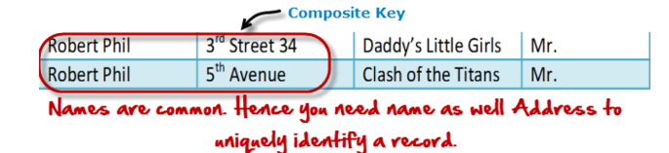

Hence, we require both Full Name and Address to identify a record uniquely. That is a composite key.

Let's move into second normal form 2NF

## 2NF (Second Normal Form) Rules

* Rule 1- Be in 1NF
* Rule 2- Single Column Primary Key

It is clear that we can't move forward to make our simple database in 2ndNormalization form unless we partition the table above.

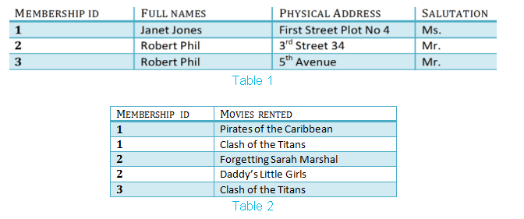

We have divided our 1NF table into two tables viz. Table 1 and Table2. Table 1 contains member information. Table 2 contains information on movies rented.

We have introduced a new column called Membership_id which is the primary key for table 1. Records can be uniquely identified in Table 1 using membership id

## Database - Foreign Key

In Table 2, Membership_ID is the Foreign Key

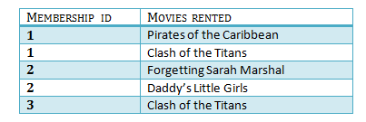

|  |  |
| --- | --- |
|  | Foreign Key references the primary key of another Table! It helps connect your Tables   * A foreign key can have a different name from its primary key * It ensures rows in one table have corresponding rows in another * Unlike the Primary key, they do not have to be unique. Most often they aren't * Foreign keys can be null even though primary keys can not |

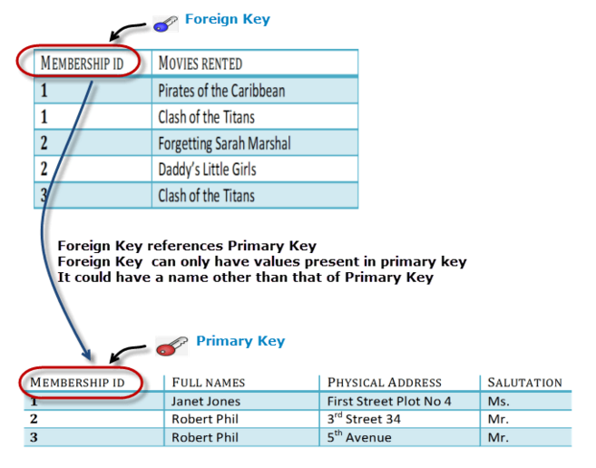

Why do you need a foreign key?

Suppose an idiot inserts a record in Table B such as

You will only be able to insert values into your foreign key that exist in the unique key in the parent table. This helps in referential integrity.

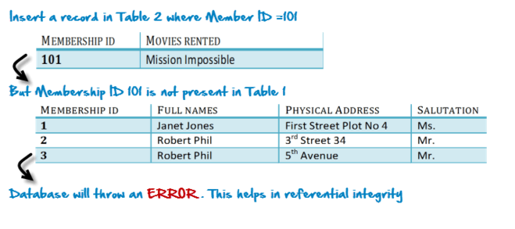

The above problem can be overcome by declaring membership id  from Table2  as foreign key of membership id from Table1

Now, if somebody tries to insert a value in the membership id field that does not exist in the parent table, an error will be shown!

## What are transitive functional dependencies?

A transitive functional dependency is when changing a non-key column, might cause any of the other non-key columns to change

Consider the table 1. Changing the non-key column Full Name may change Salutation.

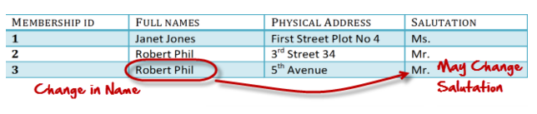

Let's move into 3NF

## 3NF (Third Normal Form) Rules

* Rule 1- Be in 2NF
* Rule 2- Has no transitive functional dependencies

To move our 2NF table into 3NF, we again need to again divide our table.

3NF Example

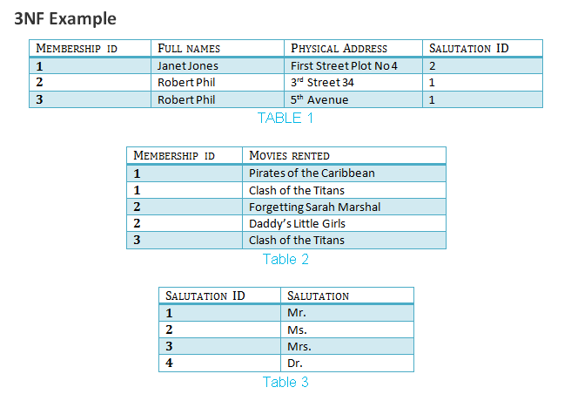

**Boyce-Codd Normal Form (BCNF)**

Even when a database is in 3rd Normal Form, still there would be anomalies resulted if it has more than one Candidate Key.

Sometimes is BCNF is also referred as 3.5 Normal Form.

**4NF (Fourth Normal Form) Rules**

If no database table instance contains two or more, independent and multivalued data describing the relevant entity, then it is in 4th Normal Form.

**5NF (Fifth Normal Form) Rules**

A table is in 5th Normal Form only if it is in 4NF and it cannot be decomposed into any number of smaller tables without loss of data.

**6NF (Sixth Normal Form) Proposed**

6th Normal Form is not standardized, yet however, it is being discussed by database experts for some time. Hopefully, we would have a clear & standardized definition for 6th Normal Form in the near future...

That's all to Normalization!!!

**Summary**

* Database designing is critical to the successful implementation of a database management system that meets the data requirements of an enterprise system.
* Normalization helps produce database systems that are cost-effective and have better security models.
* Functional dependencies are a very important component of the normalize data process
* Most database systems are normalized database up to the third normal forms.
* A primary key uniquely identifies are record in a Table and cannot be null
* A foreign key helps connect table and references a primary key

[**https://www.guru99.com/database-normalization.html**](https://www.guru99.com/database-normalization.html)

**Normalization of Database**

Database Normalization is a technique of organizing the data in the database. Normalization is a systematic approach of decomposing tables to eliminate data redundancy and undesirable characteristics like Insertion, Update and Deletion Anomalies. It is a multi-step process that puts data into tabular form by removing duplicated data from the relation tables.

Normalization is used for mainly two purposes,

* Eliminating redundant (useless) data.
* Ensuring data dependencies make sense i.e data is logically stored.

#### Problem Without Normalization

Without Normalization, it becomes difficult to handle and update the database, without facing data loss. Insertion, Updation and Deletion Anomalies are very frequent if Database is not Normalized. To understand these anomalies let us take an example of **Student** table.

|  |  |  |  |
| --- | --- | --- | --- |
| **S_id** | **S_Name** | **S_Address** | **Subject_opted** |
| 401 | Adam | Noida | Biology |
| 402 | Alex | Panipat | Maths |
| 403 | Stuart | Jammu | Maths |
| 404 | Adam | Noida | Physics |

* **Updation Anamoly :** To update address of a student who occurs twice or more than twice in a table, we will have to update **S_Address** column in all the rows, else data will become inconsistent.
* **Insertion Anamoly :** Suppose for a new admission, we have a Student id(S_id), name and address of a student but if student has not opted for any subjects yet then we have to insert **NULL** there, leading to Insertion Anamoly.
* **Deletion Anamoly :** If (S_id) 401 has only one subject and temporarily he drops it, when we delete that row, entire student record will be deleted along with it.

#### Normalization Rule

Normalization rule are divided into following normal form.

1. First Normal Form 1NF
2. Second Normal Form 2NF
3. Third Normal Form 3NF
4. BCNF

#### First Normal Form (1NF)

As per First Normal Form, no two Rows of data must contain repeating group of information i.e each set of column must have a unique value, such that multiple columns cannot be used to fetch the same row. Each table should be organized into rows, and each row should have a primary key that distinguishes it as unique.

The **Primary key** is usually a single column, but sometimes more than one column can be combined to create a single primary key. For example consider a table which is not in First normal form

**Student Table :**

|  |  |  |
| --- | --- | --- |
| **Student** | **Age** | **Subject** |
| Adam | 15 | Biology, Maths |
| Alex | 14 | Maths |
| Stuart | 17 | Maths |

In First Normal Form, any row must not have a column in which more than one value is saved, like separated with commas. Rather than that, we must separate such data into multiple rows.

**Student Table following 1NF will be :**

|  |  |  |
| --- | --- | --- |
| **Student** | **Age** | **Subject** |
| Adam | 15 | Biology |
| Adam | 15 | Maths |
| Alex | 14 | Maths |
| Stuart | 17 | Maths |

Using the First Normal Form, data redundancy increases, as there will be many columns with same data in multiple rows but each row as a whole will be unique.

#### Second Normal Form (2NF)

As per the Second Normal Form there must not be any partial dependency of any column on primary key. It means that for a table that has concatenated primary key, each column in the table that is not part of the primary key must depend upon the entire concatenated key for its existence. If any column depends only on one part of the concatenated key, then the table fails **Second normal form**.

In example of First Normal Form there are two rows for Adam, to include multiple subjects that he has opted for. While this is searchable, and follows First normal form, it is an inefficient use of space. Also in the above Table in First Normal Form, while the candidate key is {**Student**, **Subject**}, **Age** of Student only depends on Student column, which is incorrect as per Second Normal Form. To achieve second normal form, it would be helpful to split out the subjects into an independent table, and match them up using the student names as foreign keys.

**New Student Table following 2NF will be :**

|  |  |
| --- | --- |
| **Student** | **Age** |
| Adam | 15 |
| Alex | 14 |
| Stuart | 17 |

In Student Table the candidate key will be **Student** column, because all other column i.e **Age** is dependent on it.

**New Subject Table introduced for 2NF will be :**

|  |  |
| --- | --- |
| **Student** | **Subject** |
| Adam | Biology |
| Adam | Maths |
| Alex | Maths |
| Stuart | Maths |

In Subject Table the candidate key will be {**Student**, **Subject**} column. Now, both the above tables qualifies for Second Normal Form and will never suffer from Update Anomalies. Although there are a few complex cases in which table in Second Normal Form suffers Update Anomalies, and to handle those scenarios Third Normal Form is there.

#### Third Normal Form (3NF)

**Third Normal form** applies that every non-prime attribute of table must be dependent on primary key, or we can say that, there should not be the case that a non-prime attribute is determined by another non-prime attribute. So this *transitive functional dependency* should be removed from the table and also the table must be in **Second Normal form**. For example, consider a table with following fields.

**Student_Detail Table :**

|  |  |  |  |  |  |  |
| --- | --- | --- | --- | --- | --- | --- |
| **Student_id** | **Student_name** | **DOB** | **Street** | **city** | **State** | **Zip** |

In this table Student_id is Primary key, but street, city and state depends upon Zip. The dependency between zip and other fields is called **transitive dependency**. Hence to apply **3NF**, we need to move the street, city and state to new table, with **Zip** as primary key.

**New Student_Detail Table :**

|  |  |  |  |
| --- | --- | --- | --- |
| **Student_id** | **Student_name** | **DOB** | **Zip** |

**Address Table :**

|  |  |  |  |
| --- | --- | --- | --- |
| **Zip** | **Street** | **city** | **state** |

The advantage of removing transtive dependency is,

* Amount of data duplication is reduced.
* Data integrity achieved.

#### Boyce and Codd Normal Form (BCNF)

**Boyce and Codd Normal Form** is a higher version of the Third Normal form. This form deals with certain type of anamoly that is not handled by 3NF. A 3NF table which does not have multiple overlapping candidate keys is said to be in BCNF. For a table to be in BCNF, following conditions must be satisfied:

* R must be in 3rd Normal Form
* and, for each functional dependency ( X -> Y ), X should be a super Key.

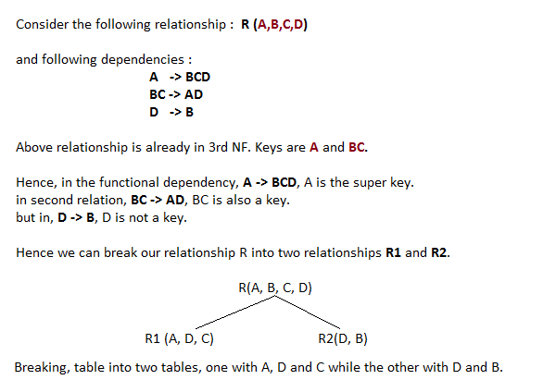

2NF

TABLE 1(std_ID,NAME,AGE,POSTCODE,CITY)

TABLE2(STD_ID,SUBJECT)

3NF

TABLE 1(std_ID,NAME,AGE,POSTCODE)

TABLE2(STD_ID,SUBJECT)

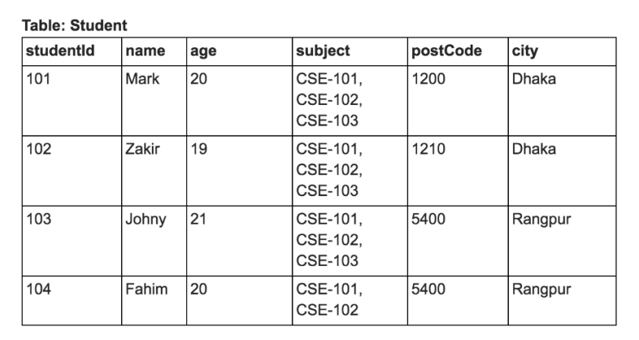TABLE3(POSTCODE,CITY)

**DBMS - Transaction**

A transaction can be defined as a group of tasks. A single task is the minimum processing unit which cannot be divided further.

Let’s take an example of a simple transaction. Suppose a bank employee transfers Rs 500 from A's account to B's account. This very simple and small transaction involves several low-level tasks.

**A’s Account**

Open_Account(A)

Old_Balance = A.balance

New_Balance = Old_Balance - 500

A.balance = New_Balance

Close_Account(A)

**B’s Account**

Open_Account(B)

Old_Balance = B.balance

New_Balance = Old_Balance + 500

B.balance = New_Balance

Close_Account(B)

## ACID Properties

A transaction is a very small unit of a program and it may contain several low level tasks. A transaction in a database system must maintain **A**tomicity, **C**onsistency, **I**solation, and **D**urability − commonly known as ACID properties − in order to ensure accuracy, completeness, and data integrity.

* **Atomicity** − This property states that a transaction must be treated as an atomic unit, that is, either all of its operations are executed or none. There must be no state in a database where a transaction is left partially completed. States should be defined either before the execution of the transaction or after the execution/abortion/failure of the transaction.
* **Consistency** − The database must remain in a consistent state after any transaction. No transaction should have any adverse effect on the data residing in the database. If the database was in a consistent state before the execution of a transaction, it must remain consistent after the execution of the transaction as well.
* **Durability** − The database should be durable enough to hold all its latest updates even if the system fails or restarts. If a transaction updates a chunk of data in a database and commits, then the database will hold the modified data. If a transaction commits but the system fails before the data could be written on to the disk, then that data will be updated once the system springs back into action.
* **Isolation** − In a database system where more than one transaction are being executed simultaneously and in parallel, the property of isolation states that all the transactions will be carried out and executed as if it is the only transaction in the system. No transaction will affect the existence of any other transaction.

## Serializability

When multiple transactions are being executed by the operating system in a multiprogramming environment, there are possibilities that instructions of one transactions are interleaved with some other transaction.

* **Schedule** − A chronological execution sequence of a transaction is called a schedule. A schedule can have many transactions in it, each comprising of a number of instructions/tasks.
* **Serial Schedule** − It is a schedule in which transactions are aligned in such a way that one transaction is executed first. When the first transaction completes its cycle, then the next transaction is executed. Transactions are ordered one after the other. This type of schedule is called a serial schedule, as transactions are executed in a serial manner.

In a multi-transaction environment, serial schedules are considered as a benchmark. The execution sequence of an instruction in a transaction cannot be changed, but two transactions can have their instructions executed in a random fashion. This execution does no harm if two transactions are mutually independent and working on different segments of data; but in case these two transactions are working on the same data, then the results may vary. This ever-varying result may bring the database to an inconsistent state.

To resolve this problem, we allow parallel execution of a transaction schedule, if its transactions are either serializable or have some equivalence relation among them.

## Equivalence Schedules

An equivalence schedule can be of the following types −

### Result Equivalence

If two schedules produce the same result after execution, they are said to be result equivalent. They may yield the same result for some value and different results for another set of values. That's why this equivalence is not generally considered significant.

### View Equivalence

Two schedules would be view equivalence if the transactions in both the schedules perform similar actions in a similar manner.

For example −

* If T reads the initial data in S1, then it also reads the initial data in S2.
* If T reads the value written by J in S1, then it also reads the value written by J in S2.
* If T performs the final write on the data value in S1, then it also performs the final write on the data value in S2.

### Conflict Equivalence

Two schedules would be conflicting if they have the following properties −

* Both belong to separate transactions.
* Both accesses the same data item.
* At least one of them is "write" operation.

Two schedules having multiple transactions with conflicting operations are said to be conflict equivalent if and only if −

* Both the schedules contain the same set of Transactions.
* The order of conflicting pairs of operation is maintained in both the schedules.

**Note** − View equivalent schedules are view serializable and conflict equivalent schedules are conflict serializable. All conflict serializable schedules are view serializable too.

## States of Transactions

A transaction in a database can be in one of the following states −

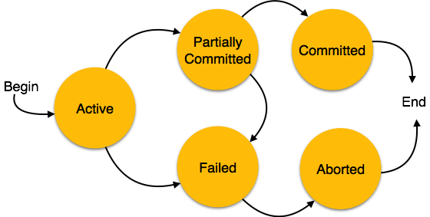

* **Active** − In this state, the transaction is being executed. This is the initial state of every transaction.
* **Partially Committed** − When a transaction executes its final operation, it is said to be in a partially committed state.
* **Failed** − A transaction is said to be in a failed state if any of the checks made by the database recovery system fails. A failed transaction can no longer proceed further.
* **Aborted** − If any of the checks fails and the transaction has reached a failed state, then the recovery manager rolls back all its write operations on the database to bring the database back to its original state where it was prior to the execution of the transaction. Transactions in this state are called aborted. The database recovery module can select one of the two operations after a transaction aborts −
  + Re-start the transaction
  + Kill the transaction
* **Committed** − If a transaction executes all its operations successfully, it is said to be committed. All its effects are now permanently established on the database system.

# DBMS - Data Backup

## Loss of Volatile Storage

A volatile storage like RAM stores all the active logs, disk buffers, and related data. In addition, it stores all the transactions that are being currently executed. What happens if such a volatile storage crashes abruptly? It would obviously take away all the logs and active copies of the database. It makes recovery almost impossible, as everything that is required to recover the data is lost.

Following techniques may be adopted in case of loss of volatile storage −

* We can have **checkpoints** at multiple stages so as to save the contents of the database periodically.
* A state of active database in the volatile memory can be periodically **dumped** onto a stable storage, which may also contain logs and active transactions and buffer blocks.
* <dump> can be marked on a log file, whenever the database contents are dumped from a non-volatile memory to a stable one.

### Recovery

* When the system recovers from a failure, it can restore the latest dump.
* It can maintain a redo-list and an undo-list as checkpoints.
* It can recover the system by consulting undo-redo lists to restore the state of all transactions up to the last checkpoint.

## Database Backup & Recovery from Catastrophic Failure

A catastrophic failure is one where a stable, secondary storage device gets corrupt. With the storage device, all the valuable data that is stored inside is lost. We have two different strategies to recover data from such a catastrophic failure −

* Remote backup & minu; Here a backup copy of the database is stored at a remote location from where it can be restored in case of a catastrophe.
* Alternatively, database backups can be taken on magnetic tapes and stored at a safer place. This backup can later be transferred onto a freshly installed database to bring it to the point of backup.

Grown-up databases are too bulky to be frequently backed up. In such cases, we have techniques where we can restore a database just by looking at its logs. So, all that we need to do here is to take a backup of all the logs at frequent intervals of time. The database can be backed up once a week, and the logs being very small can be backed up every day or as frequently as possible.

## Remote Backup

Remote backup provides a sense of security in case the primary location where the database is located gets destroyed. Remote backup can be offline or real-time or online. In case it is offline, it is maintained manually.

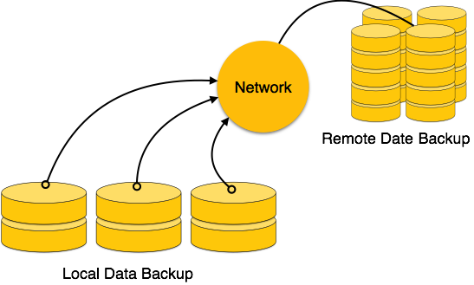

Online backup systems are more real-time and lifesavers for database administrators and investors. An online backup system is a mechanism where every bit of the real-time data is backed up simultaneously at two distant places. One of them is directly connected to the system and the other one is kept at a remote place as backup.

## As soon as the primary database storage fails, the backup system senses the failure and switches the user system to the remote storage. Sometimes this is so instant that the users can’t even realize a failure.

## Failure Classification

To see where the problem has occurred, we generalize a failure into various categories, as follows −

### Transaction failure

A transaction has to abort when it fails to execute or when it reaches a point from where it can’t go any further. This is called transaction failure where only a few transactions or processes are hurt.

Reasons for a transaction failure could be −

* **Logical errors** − Where a transaction cannot complete because it has some code error or any internal error condition.
* **System errors** − Where the database system itself terminates an active transaction because the DBMS is not able to execute it, or it has to stop because of some system condition. For example, in case of deadlock or resource unavailability, the system aborts an active transaction.

### System Crash

There are problems − external to the system − that may cause the system to stop abruptly and cause the system to crash. For example, interruptions in power supply may cause the failure of underlying hardware or software failure.

Examples may include operating system errors.

### Disk Failure

In early days of technology evolution, it was a common problem where hard-disk drives or storage drives used to fail frequently.

Disk failures include formation of bad sectors, unreachability to the disk, disk head crash or any other failure, which destroys all or a part of disk storage.

## Storage Structure

We have already described the storage system. In brief, the storage structure can be divided into two categories −

* **Volatile storage** − As the name suggests, a volatile storage cannot survive system crashes. Volatile storage devices are placed very close to the CPU; normally they are embedded onto the chipset itself. For example, main memory and cache memory are examples of volatile storage. They are fast but can store only a small amount of information.
* **Non-volatile storage** − These memories are made to survive system crashes. They are huge in data storage capacity, but slower in accessibility. Examples may include hard-disks, magnetic tapes, flash memory, and non-volatile (battery backed up) RAM.

## Recovery and Atomicity

When a system crashes, it may have several transactions being executed and various files opened for them to modify the data items. Transactions are made of various operations, which are atomic in nature. But according to ACID properties of DBMS, atomicity of transactions as a whole must be maintained, that is, either all the operations are executed or none.

When a DBMS recovers from a crash, it should maintain the following −

* It should check the states of all the transactions, which were being executed.
* A transaction may be in the middle of some operation; the DBMS must ensure the atomicity of the transaction in this case.
* It should check whether the transaction can be completed now or it needs to be rolled back.
* No transactions would be allowed to leave the DBMS in an inconsistent state.

There are two types of techniques, which can help a DBMS in recovering as well as maintaining the atomicity of a transaction −

* Maintaining the logs of each transaction, and writing them onto some stable storage before actually modifying the database.
* Maintaining shadow paging, where the changes are done on a volatile memory, and later, the actual database is updated.

The database can be modified using two approaches −

* **Deferred database modification** − All logs are written on to the stable storage and the database is updated when a transaction commits.
* **Immediate database modification** − Each log follows an actual database modification. That is, the database is modified immediately after every operation.

## Recovery with Concurrent Transactions

When more than one transaction are being executed in parallel, the logs are interleaved. At the time of recovery, it would become hard for the recovery system to backtrack all logs, and then start recovering. To ease this situation, most modern DBMS use the concept of 'checkpoints'.

### Checkpoint

Keeping and maintaining logs in real time and in real environment may fill out all the memory space available in the system. As time passes, the log file may grow too big to be handled at all. Checkpoint is a mechanism where all the previous logs are removed from the system and stored permanently in a storage disk. Checkpoint declares a point before which the DBMS was in consistent state, and all the transactions were committed.

### Recovery

When a system with concurrent transactions crashes and recovers, it behaves in the following manner −

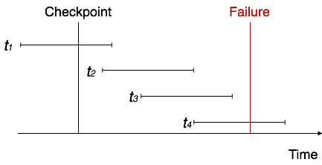

* The recovery system reads the logs backwards from the end to the last checkpoint.
* It maintains two lists, an undo-list and a redo-list.
* If the recovery system sees a log with <Tn, Start> and <Tn, Commit> or just <Tn, Commit>, it puts the transaction in the redo-list.
* If the recovery system sees a log with <Tn, Start> but no commit or abort log found, it puts the transaction in undo-list.

All the transactions in the undo-list are then undone and their logs are removed. All the transactions in the redo-list and their previous logs are removed and then redone before saving their logs.